Lab 12-01: Exploiting SCADA/ICS Systems with the Command-Line Tool, Modbus-CLI

Scenario
As a cybersecurity professional at SecureTek Solutions, a firm specializing in OT and SCADA security assessments, you have been retained to perform a formal security evaluation of a client’s SCADA/ICS environment. The client’s controllers and RTUs communicate using the Modbus protocol, and they have expressed concern about the resilience of their control-plane communications. Your primary objective is to perform an authorized, non-destructive assessment of the Modbus service to identify misconfigurations, weak access controls, and protocol-level risks while ensuring operational safety.

Solution
As a Certified Penetration Tester, you have been tasked with exploiting vulnerabilities in the SCADA system’s Modbus protocol. You can leverage a command-line tool named modbus-cli. Typically, SCADA systems utilize port 502 for Modbus communication, which is often susceptible to various security risks. Begin by identifying the SCADA system you intend to exploit. Ensure you have the necessary permissions and authorization to perform security testing on the system.
Once you have identified a target SCADA system, use modbus-cli to exploit vulnerabilities in the Modbus protocol. It may involve attempting to read or write data to critical registers, injecting malicious commands, or manipulating system behavior.
1. Open the Kali Linux terminal and type the sudo gem install modbus-cli command to install the modbus-cli tool. Press Enter.
- sudo: It allows a permitted user to execute a command as the superuser or another user, as specified in the sudoers file.
- gem: This is the command-line interface to RubyGems, which is a package manager for the Ruby programming language. It allows you to download, install, and manage Ruby libraries and programs.
- install: This is the sub-command used with a gem to specify that you want to install a gem.
- modbus-cli: This is the name of the gem you want to install.
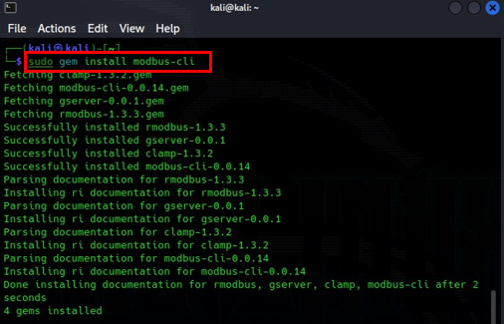
2. If you get any permission restriction error while installing the modbus-cli, then use the sudo chmod +w /var/lib/gems/3.1.0 command to grant write permission to the Ruby gems specifically for version 3.1.0. Change the version according to the error you get.
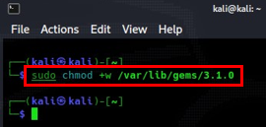
3. Type modbus and hit Enter to get its information. It has three commands: read, write, and dump.
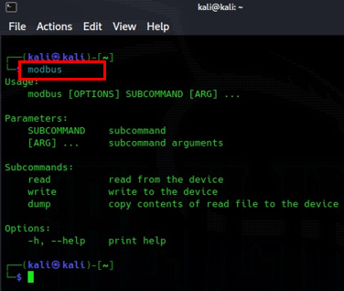
4. Use the modbus read --help command to see the usage of the read command.
5. The modbus-cli tool is specifically tailored to work with a single SCADA/ICS protocol, Modbus. While this might seem restrictive at first glance, it is worth noting that Modbus stands as the predominant communication protocol within SCADA/ICS systems. Even in cases where systems are not explicitly crafted for Modbus, manufacturers often integrate Modbus compatibility to ensure interoperability with products from other manufacturers.
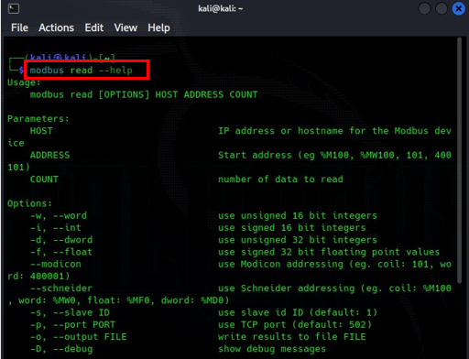

6. Now you understand how Modbus works. Go to shodan.io and search for port 502.
7. Modicon originally developed Modbus in 1979, but Schneider Electric, a French multinational corporation, has since acquired the company. Modbus usually utilizes port 502 as its default TCP port.
8. By conducting a search on Shodan for either port 502 or Schneider Electric in their search bar, you should be able to locate SCADA systems employing the Modbus protocol.
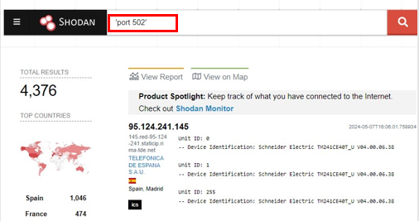
9. Click the IP Address to open its information. You can see the vendor’s name, Schneider Electric.
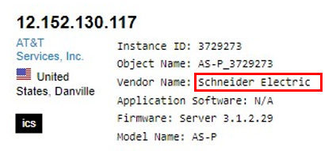
10. Use the modbus read <IP Address> %MW100 20 command to read the first twenty words from memory.
- modbus read: This indicates that you want to perform a read operation using the Modbus protocol.
- <IP Address>: This is a placeholder for the actual IP address of the Modbus device you want to communicate with. It specifies the network location of the device.
- %MW100: This is an address in the Modbus memory map. Modbus devices typically organize their data into different memory areas, such as coils, discrete inputs, input registers, and holding registers. %MW typically refers to a holding register, and 100 is the specific address within that memory area from which you want to start reading data.
11. The number 20 indicates the quantity of data you want to read. In this case, you are requesting to read 20 consecutive data values starting from address %MW100.
Note: IP Address is hidden due to privacy concerns.
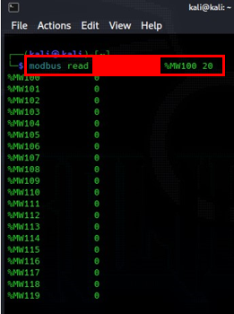
12. Use the modbus read <IP Address> 400101 20 to read the same first twenty registers, but in the Modicon terminology. It gives the same output.
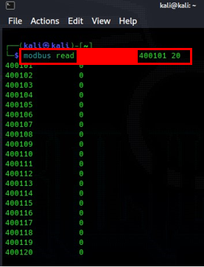
13. Refer to the following conversion chart below.
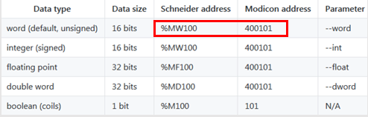
14. Use the modbus read <IP Address> %MD100 20 command to read the first twenty words from memory, but the data type is the double word.
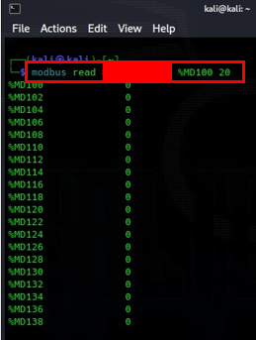
15. Use the modbus write <IP Address> 400101 2 2 2 2 2 2 command to write the data of your choice in the first six registers.
16. Use the modbus read <IP Address> 400101 20 command to read the first 20 registers, where you can see the first 6 manipulated registers whose values you just edited.
Note: Writing to the register can potentially harm the target device. Make sure you seek permission from the target before testing to avoid any legal problems. Even if the target device is in a non-production environment, it can still harm the SCADA/ICS devices.
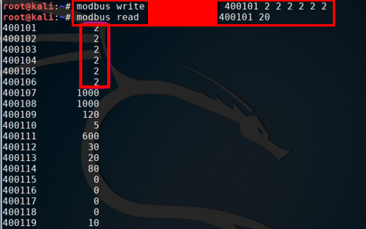
17. Use the modbus read --output dataCapture.txt <IP Address> 400101 400 command to read the first 400 registers and paste the output in the file named dataCapture.txt.
18. Use the less dataCapture.txt command to see the contents of this file one screen at a time.
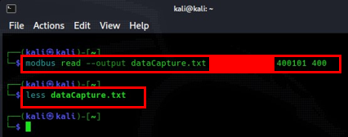
19. You can see the output of the dataCapture.txt file.
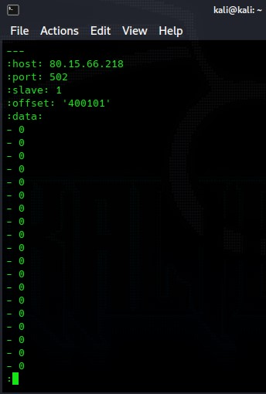

Lab 12-02: ARP-Scan for ICT System

Scenario
Amidst the bustling offices of a company, the IT department noticed a spike in network traffic, raising concerns about potential security threats. In response, the team comprehensively analyzed the company’s ICT system. Upon closer inspection, they discovered unauthorized devices attempting to access the network, posing a significant risk to sensitive data and operations. The IT team swiftly implemented ARP scanning technology to address this pressing issue. This powerful tool enabled them to conduct regular network scans, pinpointing unauthorized devices and their activity. With the insights gained from ARP scanning, the IT team swiftly identified and mitigated security vulnerabilities, bolstering the company’s defenses against potential cyber threats. As a result, a company not only safeguarded its sensitive data but also reinforced the reliability and efficiency of its ICT infrastructure, ensuring smooth operations and peace of mind for all stakeholders.

Solution
In response to the security concerns identified through ARP scanning, a company initiated a multifaceted solution to fortify its ICT system. Firstly, the IT team implemented stringent access control measures, requiring all devices to undergo thorough authentication processes before accessing the network. Additionally, they updated firewall configurations to block unauthorized access attempts and implemented intrusion detection systems to identify and respond to suspicious activity swiftly. Furthermore, the IT team conducted regular security audits and employee training sessions to educate staff on best practices for maintaining a secure network environment. By combining these measures, the company effectively mitigated potential security threats, ensuring its data and systems’ confidentiality, integrity, and availability.
- Open your Kali Linux terminal and install the arp-scan. By using the command sudo apt-get install arp-scan.
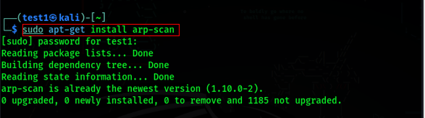
- Execute the following command: sudo arp-scan. It will help you see the options available in the tool.
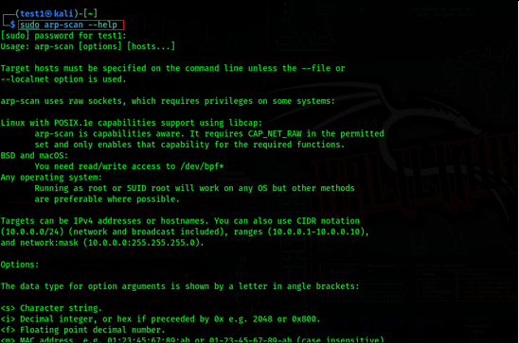
- Execute the following command: sudo arp-scan -l to see all the devices and their IP and MAC addresses.
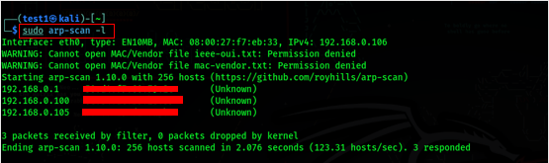
- Now, identify the network IP that you do not know.
- Then, use namp to scan that network. Also, see the open and closed ports for it.
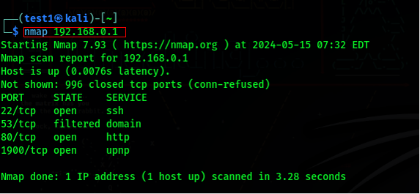

Lab 12-03: GRASSMARLIN

Scenario
A leading technology firm, it operates critical infrastructure systems that are essential for national security. Recently, they have noticed unusual network activity and suspect a potential cyber threat targeting their infrastructure. To safeguard their operations, they decided to deploy GRASSMARLIN, a network monitoring tool designed for critical infrastructure protection.

Solution
Upon detection of anomalous network activity, the firm deployed GRASSMARLIN to establish continuous, enterprise-grade monitoring of its critical infrastructure. GRASSMARLIN enables real-time analysis of network traffic, deep packet inspection for anomaly detection, and continuous asset discovery to maintain an accurate inventory. Integrated with threat intelligence feeds, it enhances detection capabilities by correlating network activity with known threats. In the event of an incident, GRASSMARLIN facilitates swift incident response and forensics analysis, ensuring the security and reliability of the firm’s operations.
1. Install GRASSMARLIN software on your Windows machine. Use the following link: https://sourceforge.net/projects/grassmarlin.mirror/ to download the GRASSMARLIN setup.
2. Open the software. The main display will open on the right side of the window and contain multiple tabs. Every Session contains a tab for, at a minimum, a Logical Graph, a Physical Graph, and Sniffles (also known as the Mesh Graph). The content of each of these tabs is referred to as a Visualization.
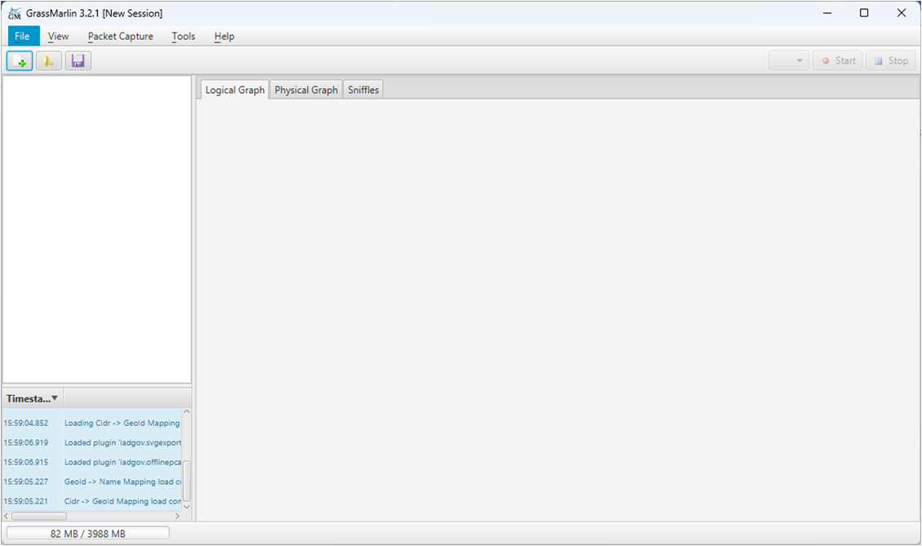
3. Now, create a new session; the Session contains imported files and visual state information. Click on the Import button from the toolbar.
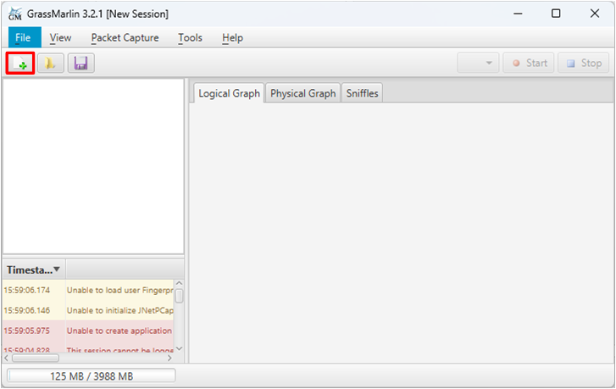
3. Click on the Add Files button to import a file item from the File menu, which will open the Import Dialog.
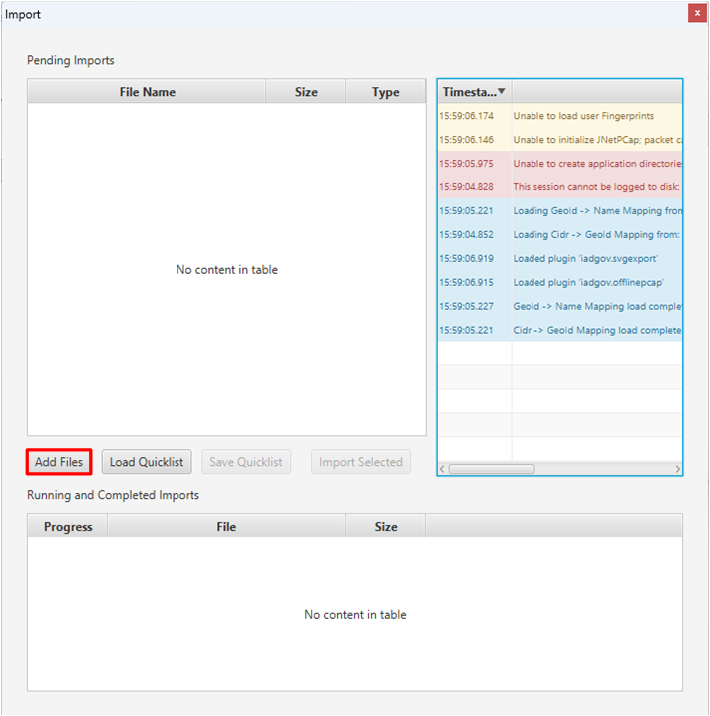
4. Now select the import type. To import a file, it must first be added to the list of Pending Imports. It associates the file with a particular data type to be imported. GRASSMARLIN will attempt to establish this association automatically by checking the file’s extension against a list of known values. If no association can be made, the user will be prompted to specify the type.
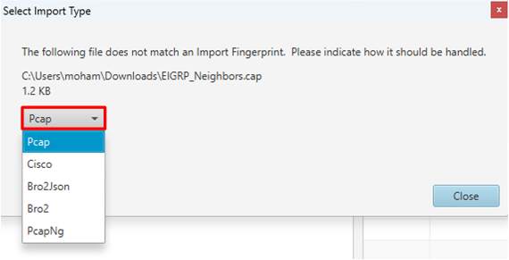
5. The association of a Pending Import can be changed. Right-click the row to be changed and select the correct type from the Context Menu.
